Game of Games Part 1: Diagrams & Use Cases

Find the Thimble Activity Diagram
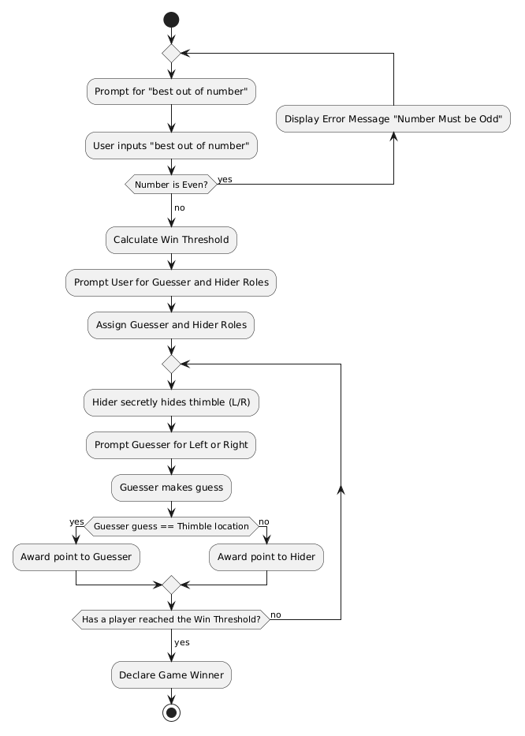

1. Use Case: Find the Thimble
- Actors: Guesser, Hider.
- Main Flow:
  - The System prompts Player 1 to specify the "best out of number".
  - Player 1 enters an odd integer.
  - The System calculates the win threshold.
  - The System prompts players to choose roles: "Who will be the Guesser?"
  - The players select whether Player 1 or Player 2 is the Guesser (the other becomes the Hider).
  - Loop Begins: The System prompts the Hider to hide the thimble secretly ('L' for Left or 'R' for Right).
  - The Hider enters 'L' or 'R' (hidden from the Guesser).
  - The System prompts the Guesser: "Which hand holds the thimble? (L/R)".
  - The Guesser enters 'L' or 'R'.
  - If the Guesser is correct, they get a point; if not, the Hider gets a point.
  - Loop Ends: The loop repeats until a player reaches the win threshold.
  - The System announces the winner.

Coin Flip Activity Diagram
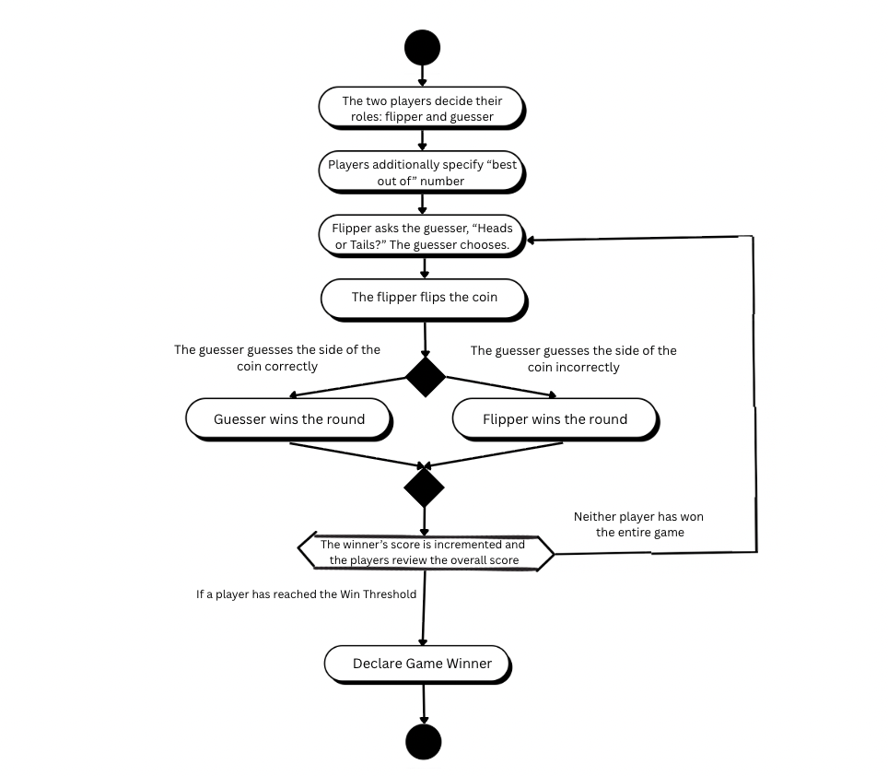

2. Use Case: Coin Flip
- Actors: Guesser, Flipper.
- Main Flow:
  - The System prompts Player 1 to specify the "best out of number" for the game.
  - Player 1 enters an odd integer.
  - The System calculates the win threshold.
  - The System prompts players to choose roles: "Who will be the Guesser?"
  - The players select whether Player 1 or Player 2 is the Guesser (the other defaults to Flipper).
  - Loop Begins: The System prompts the Guesser to call the flip: "Enter 'H' for Heads or 'T' for Tails".
  - The Guesser enters 'H' or 'T'.
  - The Flipper initiates the flip, and the System randomly generates and displays the result.
  - The System compares the Guesser's choice to the result. If it matches, the Guesser gets a point; if not, the Flipper gets a point.
  - Loop Ends: The loop repeats until a player reaches the win threshold.
  - The System announces the winner of the game.

Guess the Number Activity Diagram
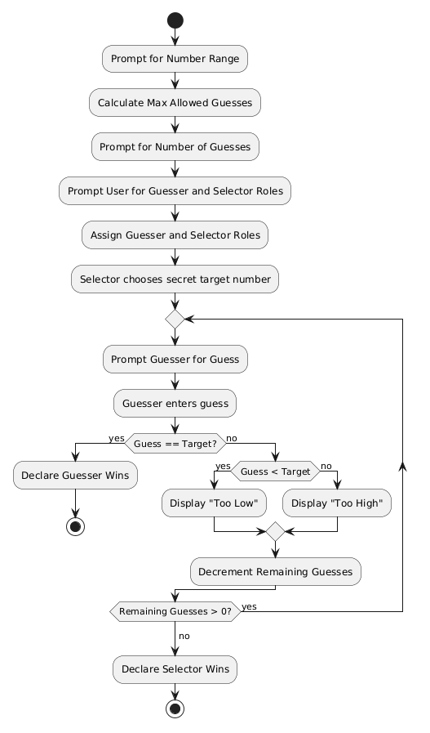
3. Use Case: Guess the Number
- Actors: Guesser, Number Selector.
- Main Flow:
  - The System prompts Player 1 to specify the maximum value for the number range.
  - Player 1 enters the maximum value.
  - The System calculates the maximum allowed guesses (half the range).
  - The System prompts for the desired number of guesses. Player 1 enters a valid number.
  - The System prompts players to choose roles: "Who will be the Guesser?"
  - Players choose roles. The other player becomes the Number Selector.
  - The Number Selector secretly enters a target number within the range (If the Selector is the Computer, it generates one randomly).
  - Loop Begins: The System prompts the Guesser: "Enter your guess".
  - The Guesser enters a number.
  - The System checks the number. If correct, the Guesser wins immediately. If incorrect, the System states whether the target is higher or lower, and decrements remaining guesses.
  - Loop Ends: The loop repeats until the Guesser gets it right or runs out of guesses.
  - The System announces the winner (Selector wins if Guesser runs out of guesses).

Even and Odd Activity Diagram
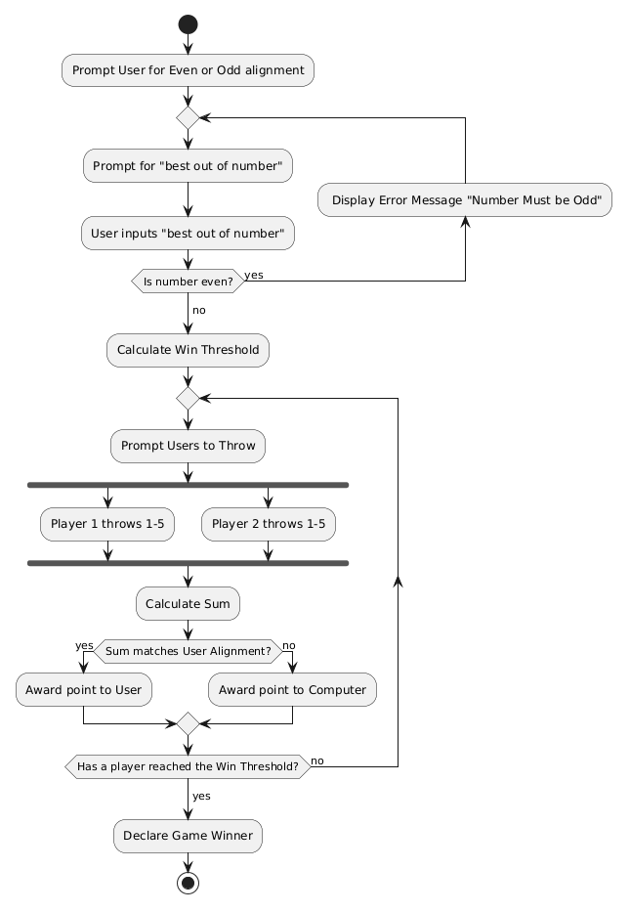
4. Use Case: Even and Odd
- Actors: Player 1, Player 2.
- Main Flow:
  - The System asks Player 1 to choose their alignment: "Even (E) or Odd (O)?". Player 2 gets the remaining alignment.
  - The System prompts for the "best out of number" (must be odd) and calculates the win threshold.
  - Loop Begins: The System prompts Player 1 to "throw" a number from 1 to 5.
  - Player 1 enters a number secretly.
  - The System prompts Player 2 to "throw" a number from 1 to 5.
  - Player 2 enters a number.
  - The System reveals both throws and calculates the sum.
  - If the sum matches Player 1's alignment, Player 1 gets a point. Otherwise, Player 2 gets a point.
  - Loop Ends: The loop repeats until a player reaches the win threshold.
  - The System announces the winner.

Find the Red Thread Activity Diagram
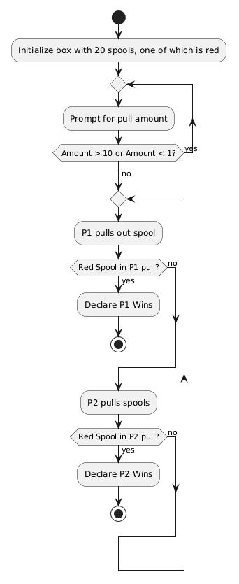
5. Use Case: Find the Red Thread
- Actors: Player 1, Player 2.
- Main Flow:
  - The System asks Player 1 how many spools to pull at a time (Max 10).
  - Player 1 enters a valid number.
  - The System asks who will pull first. Players choose Player 1 or Player 2.
  - Loop Begins: The current active player pulls the specified number of spools.
  - The System checks the pulled spools. If the red spool is found, the active player wins immediately.
  - The turn passes to the other player.
  - Loop Ends: The loop repeats until the red thread is found.

Overall Game Loop Activity Diagram
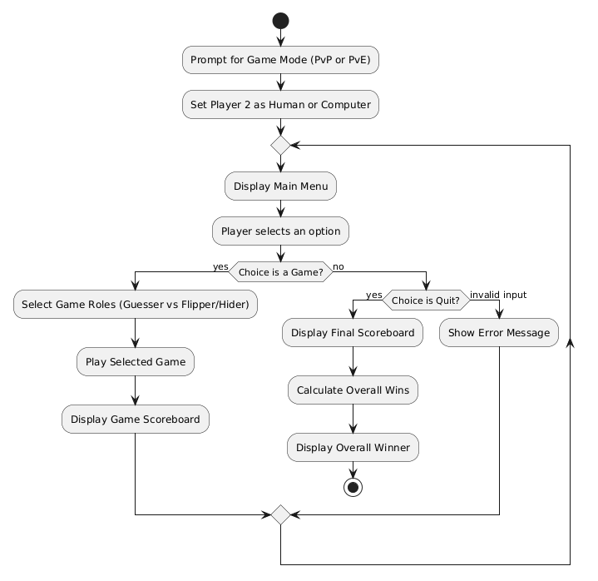6. Use Case: Overall Game of Games
- Actors: Player 1, Player 2 (Can be Human or Computer).
- Preconditions: The program is launched.
- Main Flow:
  - The System prompts the user to select a game mode: "1. Player vs Player" or "2. Player vs Computer".
  - Player 1 enters their choice. The System assigns the Player 2 role to either a human or the computer.
  - The System displays a main menu listing the five available games and a "Quit" option.
  - Player 1 enters the number corresponding to their choice.
  - The selected game executes (acts as a black box at this level).
  - Upon completion of the game, the System displays the scoreboard indicating the wins and losses for that specific game.
  - The flow returns to Step 3.
- Alternative Flow (Quit):
  - A player selects "Quit" from the main menu.
  - The System displays a final tally of the overall number of games won and lost by each player.
  - The System evaluates the totals and displays a message announcing the overall winner.

Meeting Notes, Project: Game of Games Part 1

Meeting Number:  1 | Meeting Date:  4/7/2026 | Start Time:  5:30 PM | End Time:  7:00

Attendee Name (Indicate note taker with *) | Timeliness (on time, late, left early, missing)
Ben Lyons* | On time
Juan Marcano Cuellar | On time
Sean Balbale | On time
Abby Gomes | On time

Purpose:
- Complete part 1 of game of games by creating specific diagrams to implement the programs via code in future parts

Agenda:
- Plan out how each game will flow
  - Discuss ambiguities among the games
- Create each game’s respective diagram
- Develop the use cases

Major Accomplishments:
- Created neat diagrams for every game
- Created each diagram’s corresponding use case documentation to prepare for coding

Next Steps:
- Translate diagrams/use cases into functioning code

Meeting Notes:
The meeting begins at 4:30 PM in the library. We begin by discussing how each game is played. Any ambiguities/uncertainties regarding how games are played are cleared up and agreed upon (as we all clarify how each game is played).

Next is the creation of the diagrams. We divide up who should make each diagram. Used PlantUML or Canva to efficiently create neat diagrams of how each game will flow considering two players should play it (even though when implemented, the player will only play against the computer). We put these into a document and labeled them accordingly.

Next for our use cases, we wrote them to follow the logic from our game diagrams, distinguishing unique roles players may have in a game and how each main game flows. We then put them into the same document.

Documents: (included or links to them)

GameOfGames1_BenSeanJuanAbby

